|  |  |
| --- | --- |
| **Ex:No:02** | **BOOK BANK REGISTRATION SYSTEM** |

**USE CASE DIAGRAM:**

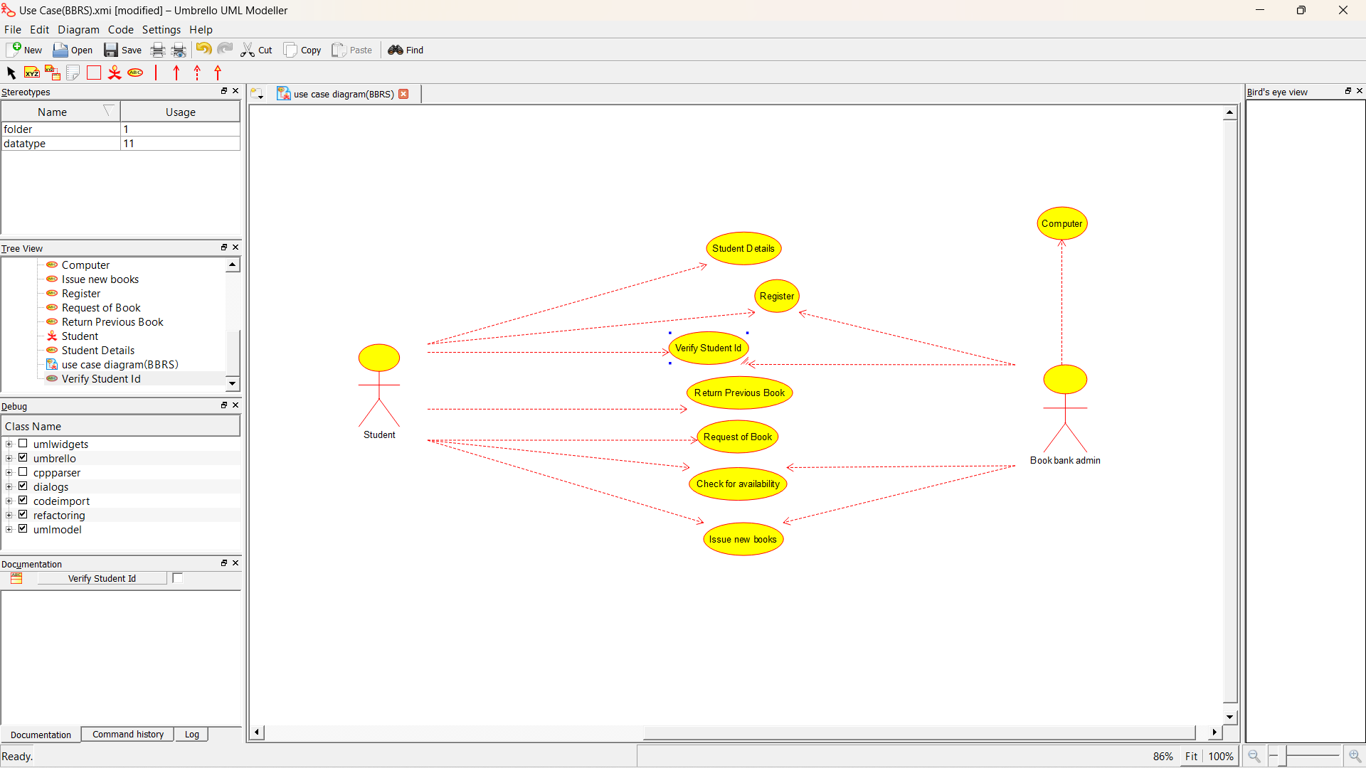

**CLASS DIAGRAM:**

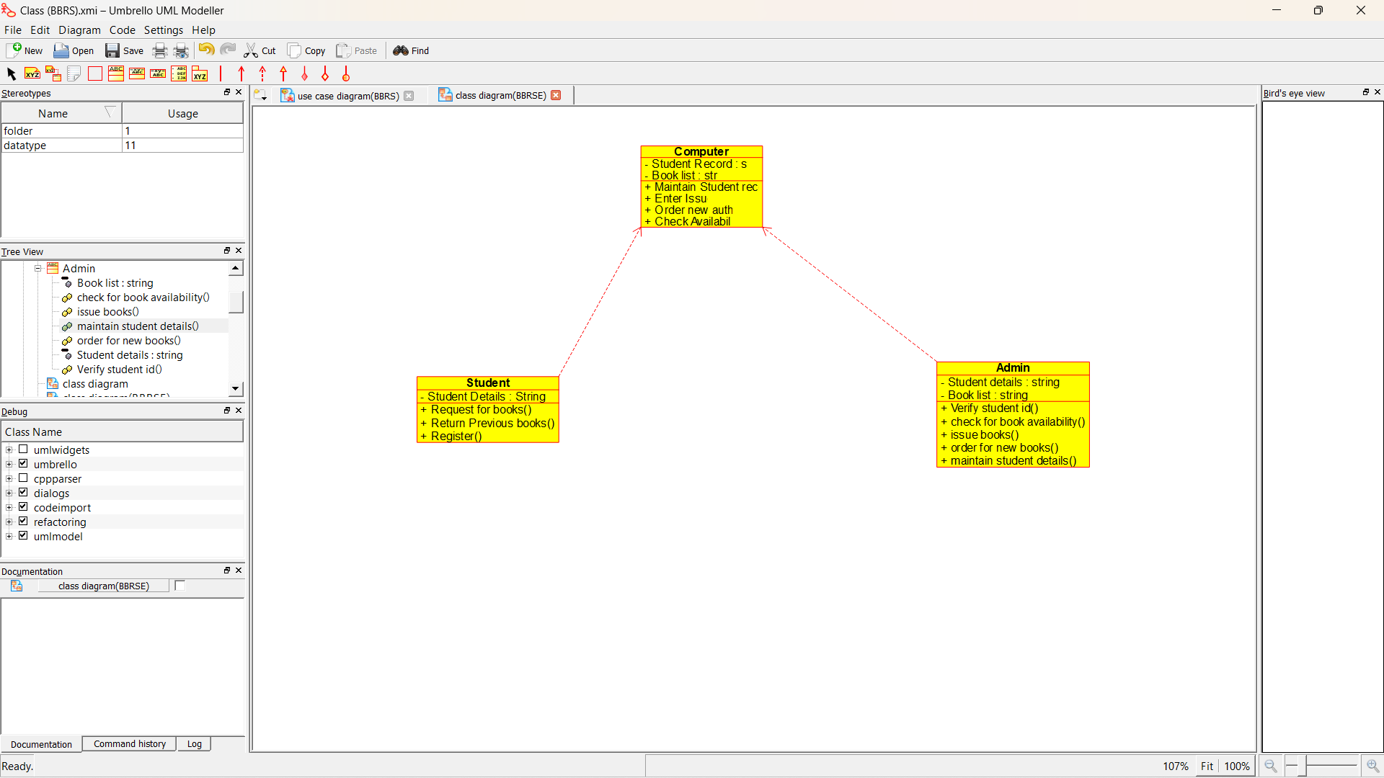

**ACTIVITY DIAGRAM:**

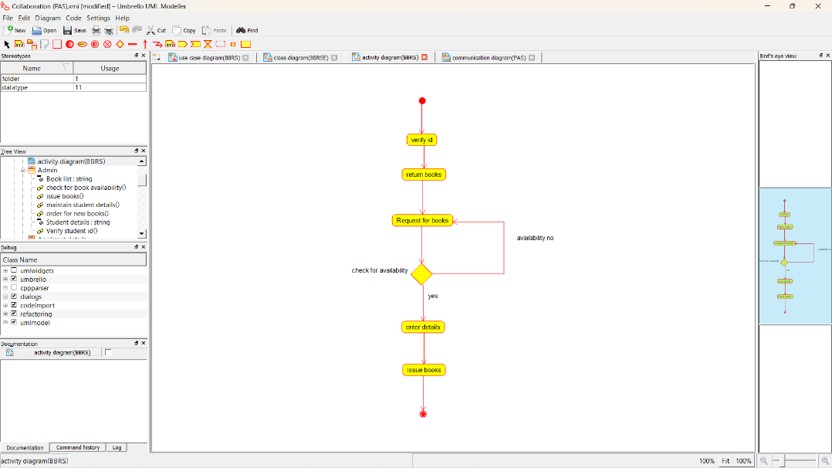

**SEQUENCE DIAGRAM:**

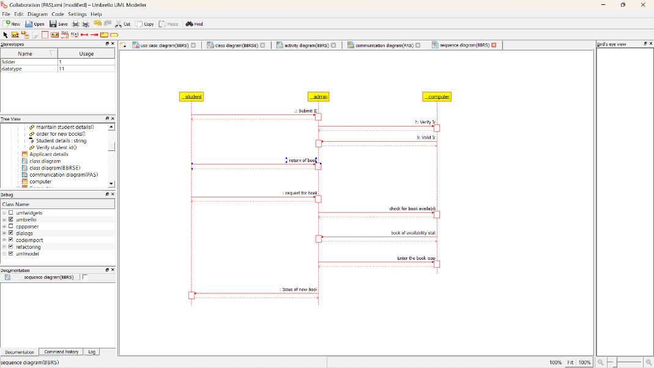

**COLLABORATION DIAGRAM:**

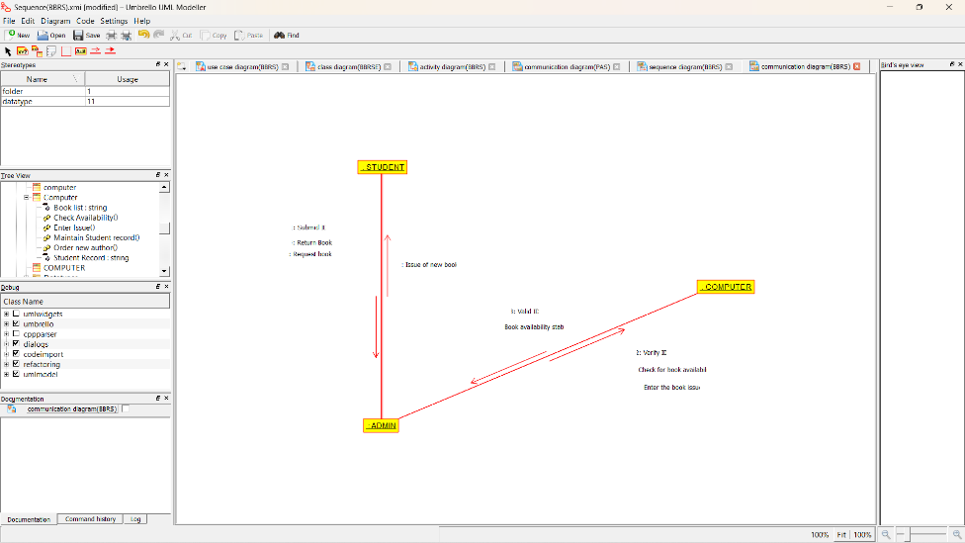

**STATE CHART DIAGRAM**

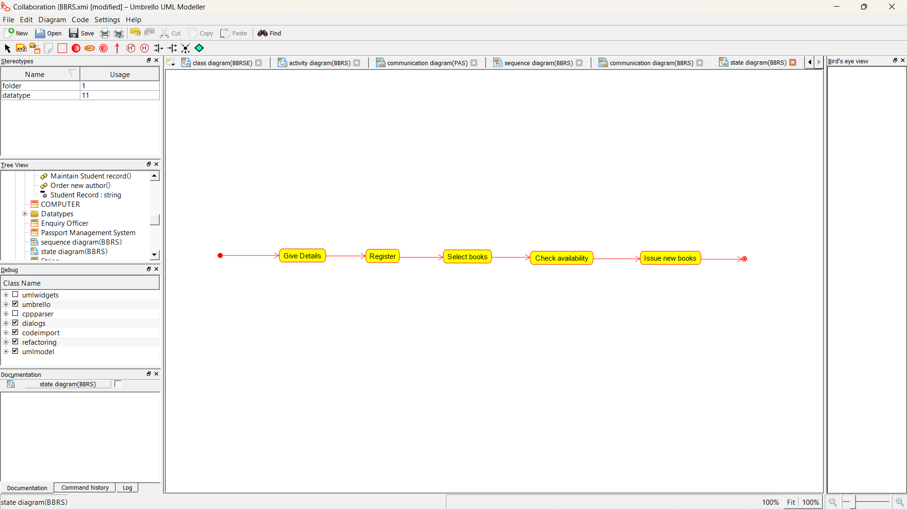

**COMPONENT DIAGRAM**

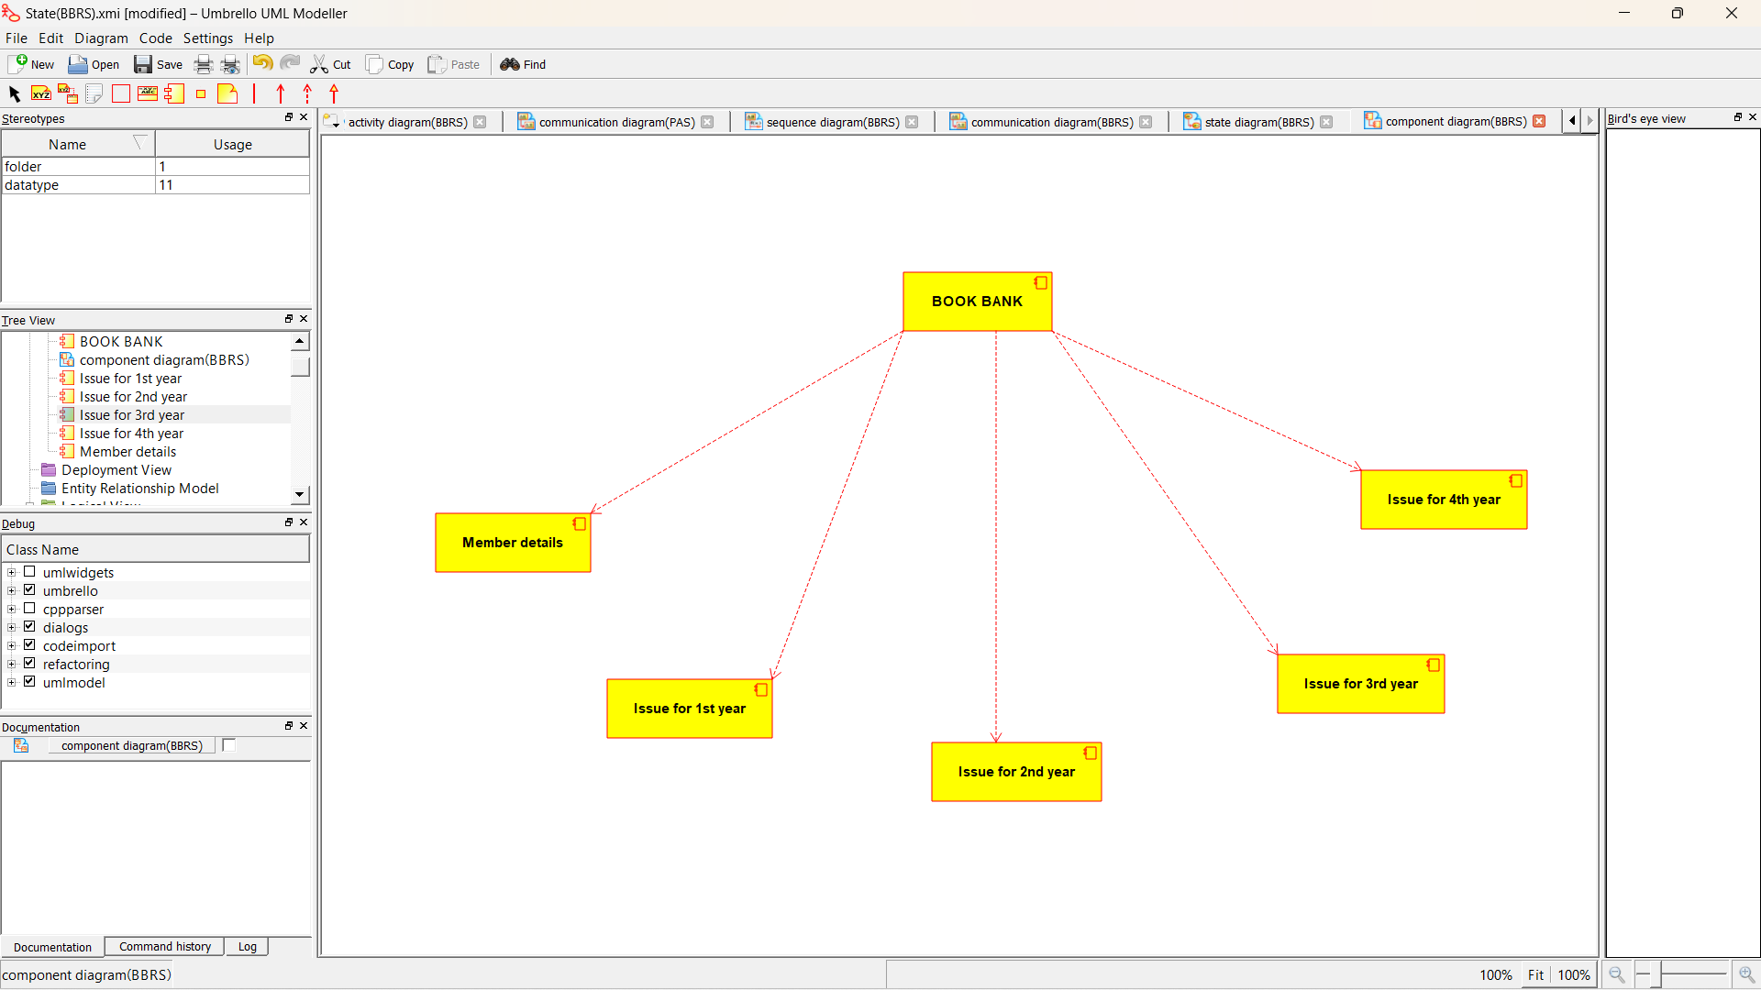

**DEPLOYMENT DIAGRAM**

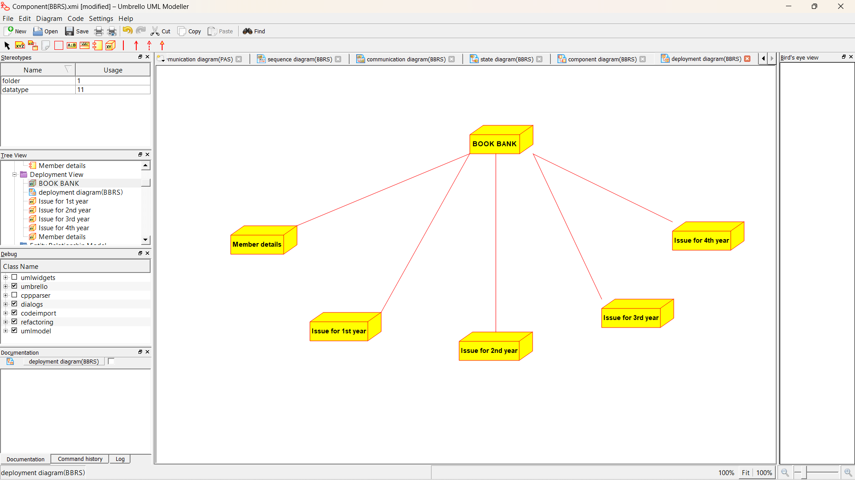

*Program coding:*

**ADMIN:**

Public class admin

{

Public integer student details;

Public integer book list;

Public void verify stud id()

{

}

Public void check for availability()

{

}

Public void issue books()

{

}

Public void order for new author()

{

}

Public void maintains stud details()

{

}

}

**STUDENT:**

Public class stud

{

Public integer studdetails;

Public void request for books()

{

}

Public void register()

{

}

**COMPUTER:**

Public class computer

{

Public integer stud record;

Public integer booklist;

Public void maintain stud rec()

{

}

Public void enter issue()

{

}

Public void order new author()

{

}

Public void check availability()

{

}

}